e-Waste Warriors – school pack

We have put together this pack for schools, which includes:

Teacher’s briefing document (this document)
○ Who are Recycle Your Electricals?
○ Background on e-waste and how to recycle
○ Introduction to e-Waste Warriors

Project planning and guidance
○ Planner with dates and links for the 4-week project period
○ FAQ document
○ Guidance on running and storing the bins
○ Risk assessment

PowerPoint presentation
○ Assembly slides

Team Repair
○ All the Team Repair kit guidance, presentations and activities can be found here: Retro Games Console Resource Pack (V2)

HypnoCat myth-busting videos
○ (very) short videos about reusing and recycling electricals

Pack of ready-to-use communications resources
○ Promoting The Great Cable Challenge in your school
○ A2 promotional poster for window x 1
○ A2 repair event promotional poster for window x 1
○ Pre-written email to parents for promotion of recycling bins
○ Pre-written email to parents for promotion of repair event
○ PDF ready A3 and A4 poster templates for promotion of recycling and repair events
Other resources
○ 1 x recycling collection pink wheelie bin (lighter pink sticker)
○ 1 x repair collection pink wheelie bin (darker pink sticker)
○ 2 x additional bins at one specified school (NLL)

Teacher’s briefing document

Who are Recycle Your Electricals?

Recycle Your Electricals is a UK-wide campaign motivating and making it easier for
everyone to reuse and recycle unwanted electricals, ensuring we make the most of the valuable materials in them.

The campaign is led by Material Focus, an independent not-for-profit organisation on a mission to transform the way we think about our unwanted electricals – from useless waste to valuable resources.

Meet HypnoCat

HypnoCat is our recycled-obsessed mascot on a mission to hypnotise the nation into recycling all their old, wanted electricals. Look into his eyes and you wiiillll feel a sudden, overwhelming urge to bag up your old electricals for recycling.



Background on e-waste and how to recycle

Electrical waste, also known as e-waste, is any broken or unwanted electrical or
tech item with either a plug, battery or cable.

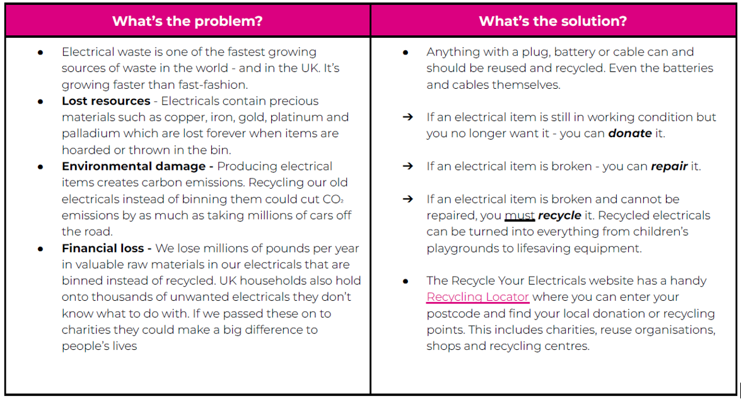

Find out more about the problem with e-waste here.
Find out more about the benefits of recycling here.
Find the Recycling Locator here.
problem? What’s the solution?
Key messages:

● Everything with a plug, battery or cable can be recycled. Even the batteries and
cables themselves.
● There are hidden batteries within electricals which can start fires when crushed
or damaged inside bin and recycling lorries.
● Never bin loose or hidden batteries.
● Remove batteries from electricals before recycling. If you’re unable to remove
the battery safely, recycle it together with your old electricals.
● You may need assistance with the safe removal of batteries from electrical
items, please ask a responsible adult to help with this
● Search Recycle Your Electricals to find all your local electrical and battery drop-off points: www.recycleyourelectricals.org.uk

Introduction to e-Waste Warriors

We (Kent County Council) are excited to announce our application for the Electrical Recycling Innovation Fund has been approved by Material Focus for the full value of £50,000. The project will focus on increasing recycling and repair rates of small electrical goods in schools across Kent by engaging students using innovative Team Repair kits (kits that teach children how to fix broken gadgets). Combined with recycling and repair bins, assemblies and a repair event in schools, the project hopes to raise awareness, teach repair (STEM) skills and build networks across communities that encourage the next generation and their families to engage in the circular economy.

The project will be focused on small, localised clusters of five schools with a potential for five or six clusters in different areas over the year-long timescale. Maidstone will be the first cluster, with the other clusters to be determined by interest from schools to take part. Up to 30 schools will be actively involved in the project that will be advertised to over 700 schools in Kent, who are eligible to take part. Approximately 3,000 students will take part in the Team Repair activities with a reach of approx. 18,000 students for recycling and repair collection. Further press releases and communications will increase the reach of recycling and repair messages across the county.

We have a competition running as clusters, with most weight recycled, and most items repaired receiving prizes. We have a budget for each section of £1,000 to be split over five schools in each winning cluster. Winners of the recycling prizes will receive £200 vouchers for recycled plastic furniture (or anything else from leading UK supplier of British Recycled Plastic products). Winners of the repair prizes will receive £200/£400 vouchers for repaired IT equipment from RDUK.

